Question A

1) SELECT STUDENT_NAME FROM STUDENT WHERE GENDER="Male" AND BIRTHDATE=’1995-01-01’

2) SELECT STUDENT_NAME FROM STUDENT ORDERY BY STUDENT_NAME

WHERE LEN(STUDENT_NAME)>=5 AND BIRTHDATE>=’1995-01-01’ AND BIRTHDATE<=’2000-01-01’

3) SELECT COURSE_TITLE FROM COURSE WHERE EXISTS

(SELECT STAFF_ID FROM STAFF WHERE COURSE.STAFF_ID=STAFF.STAFF_ID AND NOT (STAFF_NAME=’SMITH’ OR STAFF_NAME=’JONES’)

4) SELECT COUNT(COURSE_ID), SECTION FROM COURSE GROUP BY SECTION ORDER BY SECTION

5) SELECT STAFF_NAME FROM STAFF WHERE BOSS_ID

6) SELECT * FROM STAFF WHERE SALARY>(SELECT AVERAGE(SALARY) FROM STAFF)

7) SELECT STAFF_NAME FROM STAFF WHERE STAFF_ID IN (SELECT BOSS_ID FROM STAFF) AND DEPARTMENT=’Accounting’

8) SELECT COUNT(DISTINCT STAFF.STAFF_ID) / (COUNT(COURSE.STAFF_ID))

FROM STAFF LEFT JOIN COURSE ON STAFF.STAFF_ID = COURSE.STAFF_ID

Question B

Select σ, RENAME ρ, union U, intersection ∩, difference - , cartesian product **x** , project π, join ⋈

1) EDEPENDENT <- EMPLOYEE ⋈ Ssn=Essn DEPENDENT

RESULT <- π Fname,Lname (EDEPENDENT)

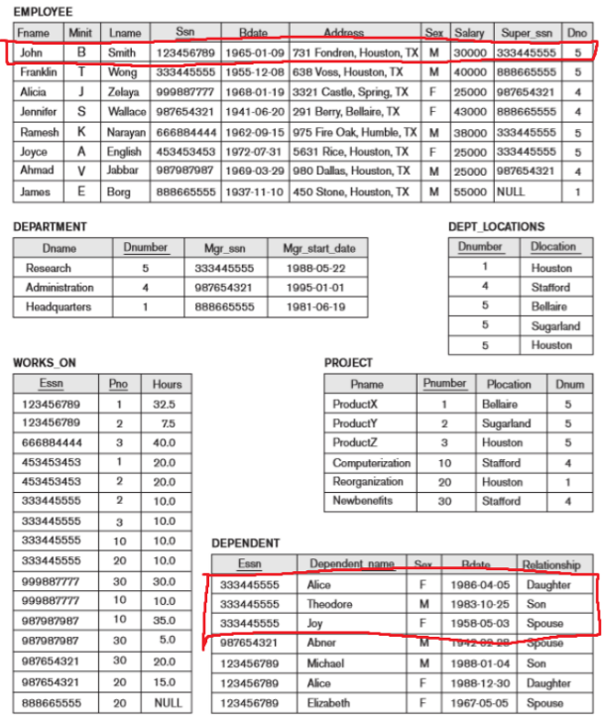 Then repeat for each one to create the new table

2) SALARY39 <- EMPLOYEE ⋈ Dno=Dnumber AND Salary<39000 DEPARTMENT

RESULT <- π Fname (σ Dname=’Research’ (SALARY39))

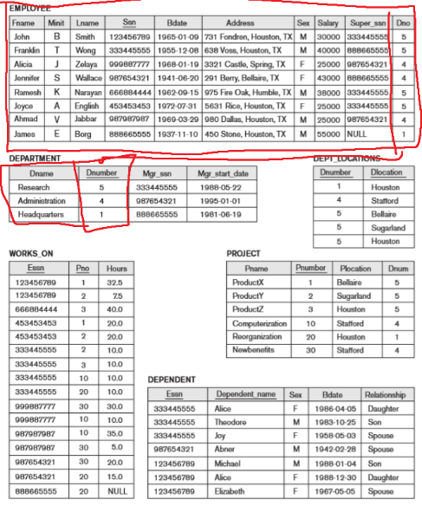

3) JENNI <- σ Fname=’Jennifer’ Lname=’Wallace’ (EMPLOYEE)

JENNI_SSN <- π Ssn (JENNI)

RESULT <- π Fname (σ Super_ssn != JENNI_SSN AND Sex=’M’ (EMPLOYEE))

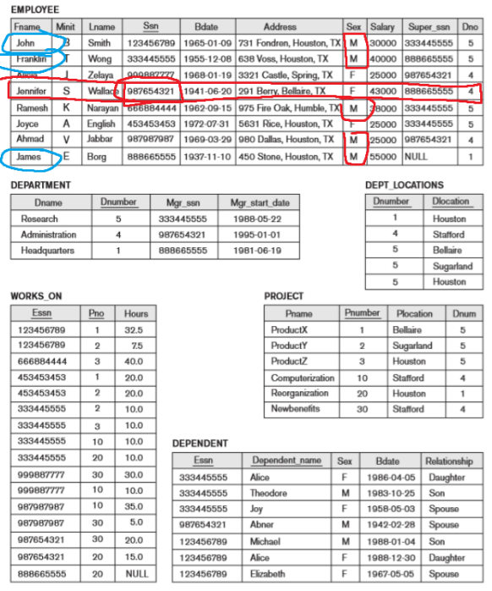

4) FDEPENDENT <- σ Relationship=’Daughter’ (DEPENDENT)

EMP <- EMPLOYEE ⋈ Ssn=Essn FDEPENDENT

NEWB_NUM <- π Pnumber (σ Pname=’Newbenefits’ PROJECT)

WORKS_NEWB <- WORKS_ON ⋈ Pno=NEWB_NUM PROJECT

RESULT <- π Fname (EMP ∩ WORKS_NEWB)

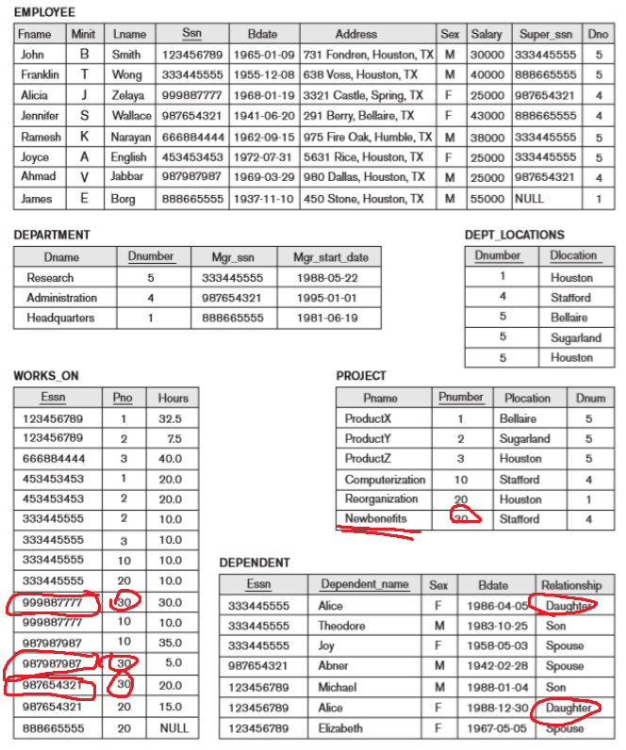

5) PROJE <- π Pno, Essn (WORKS_ON)

ALL_PROJ <- π Pnumber (PROJECT)

EMP_ALL <- PROJE DIVISION ALL_PROJ

RESULT <- π Fname (EMPLOYEE ∩ EMP_ALL)

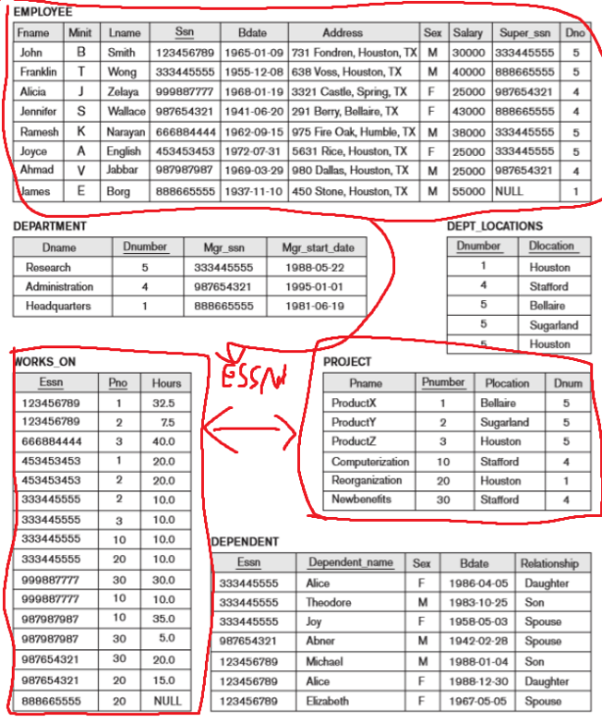

6) PROJE <- π Pno, Essn (WORKS_ON)

EMP_NOT <- π Essn (EMPLOYEE) – π Essn (PROJE)

RESULT <- π Fname (EMPLOYEE ∩ EMP_ NOT)

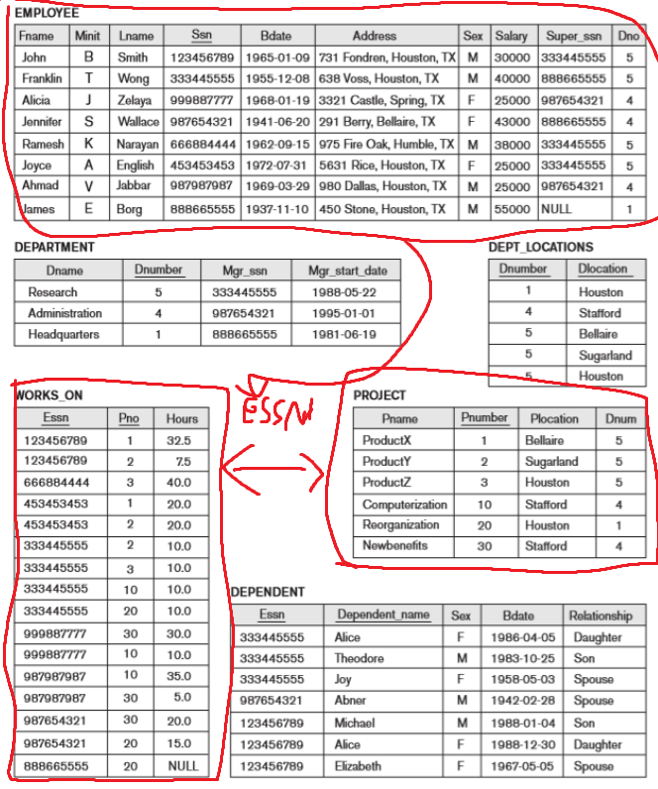

7) REQ_EMP <- σ Sex=’M’ AND Dno=’4’ (EMPLOYEE)

RESULT <- π Salary (REQ_EMP)

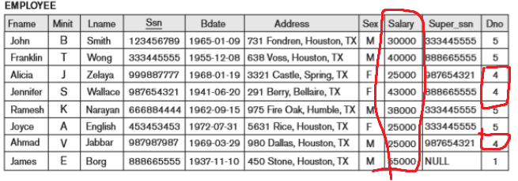

8)

9) SDEPENDENT <- σ Relationship=’Spouse’

JOINED <- DEPARTMENT ⋈ Mgr_ssn = Essn SDEPENDENT

NAME_LIST <- JOINED ⋈Mgr_ssn = Ssn EMPLOYEE

RESULT <- π Lname (NAME_LIST)

